**Assignment 3:** In this assignment, we practice J2EE Database Programming using JSP/JSTL.

**Part A)** Design the following Database /Table using *MySQL WorkBench*

1. Create a new database in MySQL .
   * Database Name : A3
2. Create a new Table in MySQL.
   * Table Name is **PRODUCT** which has the following structure:

|  |  |  |  |  |  |
| --- | --- | --- | --- | --- | --- |
| ProductNo | ProductName | ProductType | Manufacturer | Price | Weight |
| Varchar(5),  PrimaryKey | Varchar(25) | Varchar(25) | Varchar(25) | Decimal  xxx.xx | Decimal  xx.xx |

**Part B)** Create a new Web Application and develop the following **JSP pages** to interact with a MySQL server (as demonstrated in class):

1. Develop the following JSP page ( name it **Add-Product-Form.jsp**)

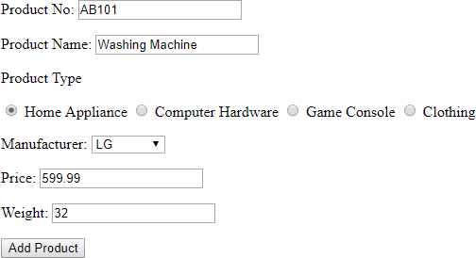

Add the proper tags which display the following message when user clicks on add product button:

# The following information is received:

Product No is AB101

Product name is Washing Machine Product type is Home Applience

Manufacturer is LG Price is 599.99 Weight is 32

1. Save **Add-Product-Form.jsp** as **Insert-records.jsp** , remove the EL commands for displaying the message and add the following functionality.
   1. When user clicks on **Add Product** button, the program reads the form data and inserts them into the **PRODUCT** table using JSTL core and sql libraries.
   2. The program perform form validation to ensure the Price range of each product is between $100~$900
   3. The program will displays all existing records of **PRODUCT** in HTML table format.

***NOTE****: the page shouldn’t insert any record until user press the* ***Add Product*** *button. However, when user opens the page, the form and the existing records can be displayed!*

<%@ page language=*"java"* contentType=*"text/html; charset=ISO-8859-1"*

pageEncoding=*"ISO-8859-1"*%>

<%@ taglib uri= *"http://java.sun.com/jsp/jstl/core"* prefix=*"c"* %>

<%@ taglib uri= *"http://java.sun.com/jsp/jstl/sql"* prefix=*"sql"* %>

<!DOCTYPE html>

<html>

<head>

<meta charset=*"ISO-8859-1"*>

<meta charset=*"utf-8"*>

<meta name=*"viewport"* content=*"width=device-width, initial-scale=1"*>

<link rel=*"stylesheet"* href=*"https://maxcdn.bootstrapcdn.com/bootstrap/3.4.1/css/bootstrap.min.css"*>

<script src=*"https://ajax.googleapis.com/ajax/libs/jquery/3.6.0/jquery.min.js"*></script>

<script src=*"https://maxcdn.bootstrapcdn.com/bootstrap/3.4.1/js/bootstrap.min.js"*></script>

<title>Assignment 3- Step 1</title>

<style>

*.column* {

float: *left*;

width: *25%*;

}

**table** {

font-family: *arial, sans-serif*;

border-collapse: *collapse*;

width: *100%*;

}

**td,** **th** {

border: *1px solid #dddddd*;

text-align: *left*;

padding: *8px*;

}

**tr***:nth-child*(*even*) {

background-color: *#dddddd*;

}

</style>

</head>

<body>

<sql:setDataSource

var=*"db"*

driver=*"com.mysql.jdbc.Driver"*

url=*"jdbc:mysql://localhost:3306/assignment3"*

user=*"root"*

password=*""*/>

<form method = *"post"* >

<pre>

productNo: <input type=*"text"* name=*"productNo"*>

productName: <input type=*"text"* name=*"productName"*><br>

productType:

<div class=*"column"*>

<input type=*"radio"* name=*"productType"* margin-right: 0 checked value =*"Home Appliances"*>Home Appliances

</div>

<div class=*"column"*>

<input type=*"radio"* name=*"productType"* margin-right: 0 value = *"Computer Hardware"*>Computer Hardware

</div>

<div class=*"column"*>

<input type=*"radio"* name=*"productType"* style="margin-right: *0*" value =*"Game Console"*>Game Console

</div>

<div class=*"column"*>

<input type=*"radio"* name=*"productType"* style="margin-right: *0*" value =*"Clothing"*>Clothing

</div>

<br>

<br>

manufacturer: <input type=*"text"* name=*"manufacturer"*>

price: <input type=*"number"* name=*"price"*>

<c:if test = *"*${(param.price < 100) && (param.price > 900)}*"*>

<p>Try again!Enter a value between $100 to $900</p>

price: <input type=*"text"* name=*"price"*>

</c:if>

weight: <input type=*"text"* name=*"weight"*>

<input type=*"submit"* value=*"Add Product"*>

</pre>

</form>

<p>The following information is received:</p>

Product No is <c:out value=*"*${param.productNo}*"*/><br>

Product Name is <c:out value=*"*${param.productName}*"* /><br>

Product Type is <c:out value=*"*${param.productType}*"* /><br>

Manufacturer is <c:out value=*"*${param.manufacturer}*"* /><br>

Price is <c:out value=*"*${param.price}*"* /><br>

Weight is <c:out value=*"*${param.weight}*"* /><br>

<sql:update dataSource=*"*${db}*"* var=*"count"*>

INSERT INTO product VALUES('${param.productNo}','${param.productName}','${param.productType}','${param.manufacturer}',

'${param.price}', '${param.weight}')

</sql:update>

<sql:query dataSource=*"*${db}*"* var=*"rs"*>

select * from product;

</sql:query>

<br>

<table>

<tr>

<th>ProductNo</th>

<th>ProductName</th>

<th>ProductType</th>

<th>Manufacturer</th>

<th>Price</th>

<th>Weight</th>

</tr>

<c:forEach var=*"row"* items=*"*${rs.rows}*"*>

<tr>

<td>${row.productNo}</td>

<td>${row.productName} </td>

<td>${row.productType} </td>

<td>${row.manufacturer}</td>

<td>${row.price}</td>

<td>${row.weight}</td>

</tr>

</c:forEach>

</table>

</body>

</html>

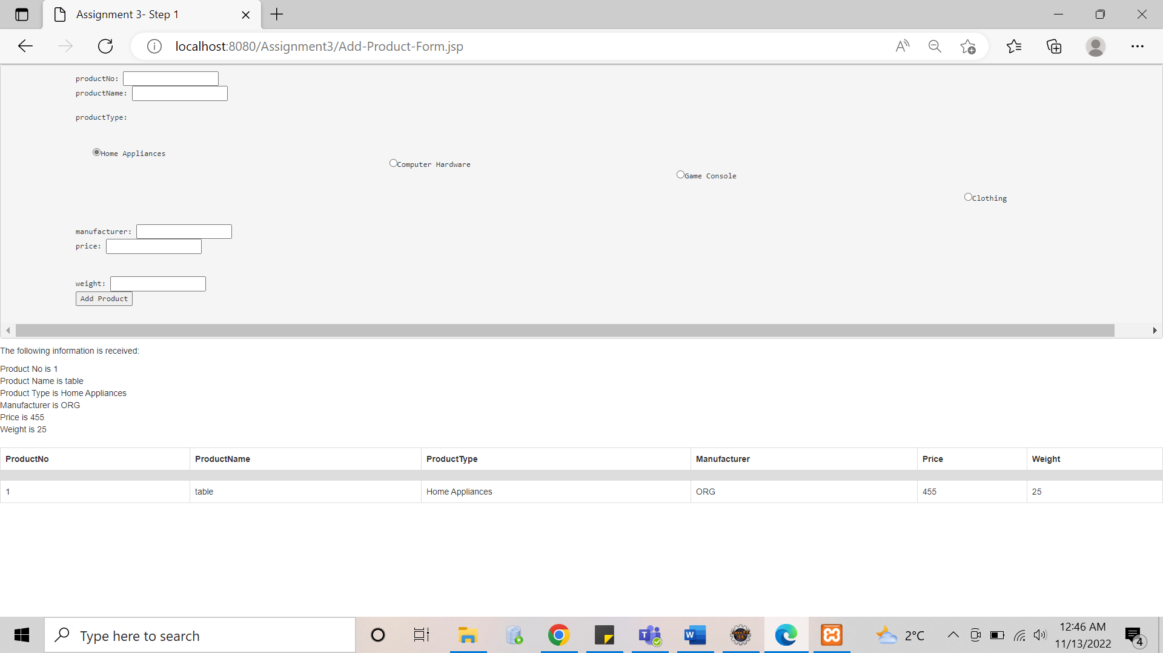

1. Develop a JSP page (name it **Delete-Records**), which displays the following form and delete all related record from the **PRODUCT** table, using JSTL core and sql libraries. The program displays the remaining records of **PRODUCT** in HTML table format below the “Delete the Product” button.

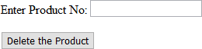

<%@ page language=*"java"* contentType=*"text/html; charset=ISO-8859-1"*

pageEncoding=*"ISO-8859-1"*%>

<%@ taglib uri= *"http://java.sun.com/jsp/jstl/core"* prefix=*"c"* %>

<%@ taglib uri= *"http://java.sun.com/jsp/jstl/sql"* prefix=*"sql"* %>

<!DOCTYPE html>

<html>

<head>

<meta charset=*"ISO-8859-1"*>

<title>Delete Record</title>

<style>

**table** {

font-family: *arial, sans-serif*;

border-collapse: *collapse*;

width: *100%*;

}

**td,** **th** {

border: *1px solid #dddddd*;

text-align: *left*;

padding: *8px*;

}

**tr***:nth-child*(*even*) {

background-color: *#dddddd*;

}

</style>

</head>

<body>

<sql:setDataSource

var=*"db"*

driver=*"com.mysql.jdbc.Driver"*

url=*"jdbc:mysql://localhost:3306/assignment3"*

user=*"root"*

password=*""*/>

<form>

<pre>

Enter Product Number: <input type=*"text"* name=*"productNo"*>

<input type=*"submit"* value=*"Delete Product"*>

</pre>

</form>

<c:set var=*"productNo"*/>

<sql:update dataSource=*"*${db}*"* var=*"count"*>

DELETE FROM product WHERE productNo = ?

<sql:param value=*"*${param.productNo}*"* />

</sql:update>

<sql:query dataSource=*"*${db}*"* var=*"rs"*>

select * from product;

</sql:query>

<br>

<table>

<tr>

<th>ProductNo</th>

<th>ProductName</th>

<th>ProductType</th>

<th>Manufacturer</th>

<th>Price</th>

<th>Weight</th>

</tr>

<c:forEach var=*"row"* items=*"*${rs.rows}*"*>

<tr>

<td>${row.productNo}</td>

<td>${row.productName} </td>

<td>${row.productType} </td>

<td>${row.manufacturer}</td>

<td>${row.price}</td>

<td>${row.weight}</td>

</tr>

</c:forEach>

</table>

</body>

</html>

**Part C)** Open the *sample.jsp* file. Using your own word, explain the followings:

* How does this program work?

It is a jsp program that runs based on the numeric format functions.

* What is the purpose of using c:set, fmt:formatNumber?

C:set function assigning the values to the variable “num”.

Fmt:formatNumber is the number formatting functions like currency which adds , as per the currency rules. Then defining how much number we want before and after decimal.

**Part D)** Develop a new JSP page using the following snippet:

<p> step 1: </p>

<%!**int** p=500; %>

<%=p %>

<p> step 2: </p>

<c:set var=*"q"* value=*"600"* />

<c:out value=*"*${q}*"*/>

<c:out value=*"*${p}*"*/>

<p> step 3: </p>

<p>${p} ${q}</p>

1. Using your own word, explain how this code works.
2. You may notice that some of the expected values are not being displayed. Why? How to fix this issue? **You need to explain your answer in 60~100 words.**

<%!**int** p = 500;%> declaring variable with its initial value.

<%=p%> is dynamic content like whatever number we will provide in the line number 13 that will get assigned to p.

Then in step 2 we are only setting the value for Q. So in step2 and step3 only prints q not p.

So I have set the value for variable p as well. Now it is printing both p and q in step 2 and 3.

# Submission:

Take screenshot of the project in your IDE (the structure of files/libraries) and add some screenshot to show how the web application works. Save the screenshots in MS-Word file.

Submit the followings:

1. Submit the video recording.
2. Also submit
   1. MS-word file (answer to the questions + screenshots)
   2. The web application (ZIP format)
   3. Export the database (.sql)